ALL REPORT CODING

Start

Login page(Chai Yi Bing)

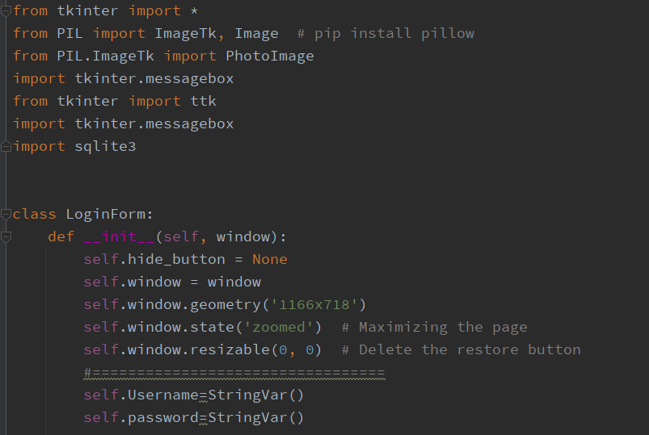

Here is all the import and the class of login form which used to be a page name(indication).

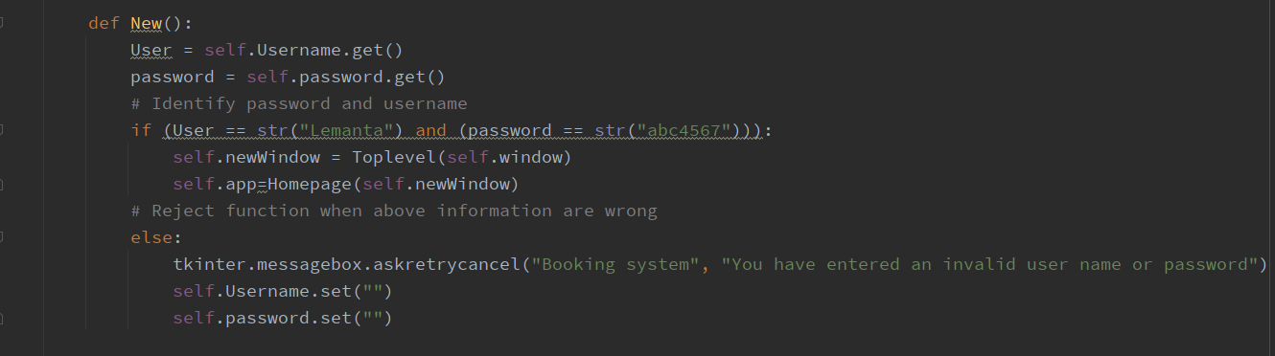

Here is the code for login system and function for link to a new page/window

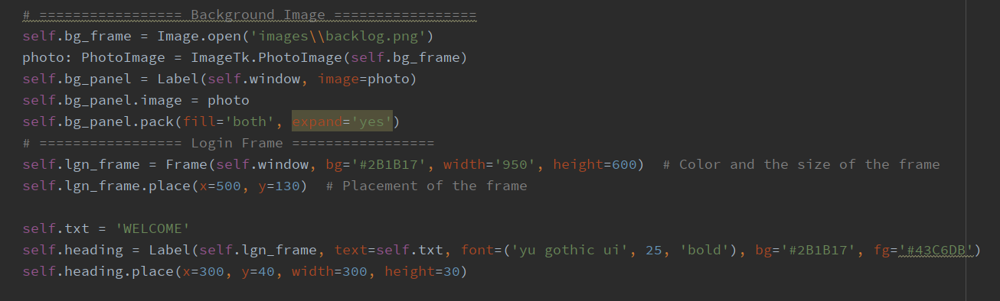

This is the code for background image and log in frame

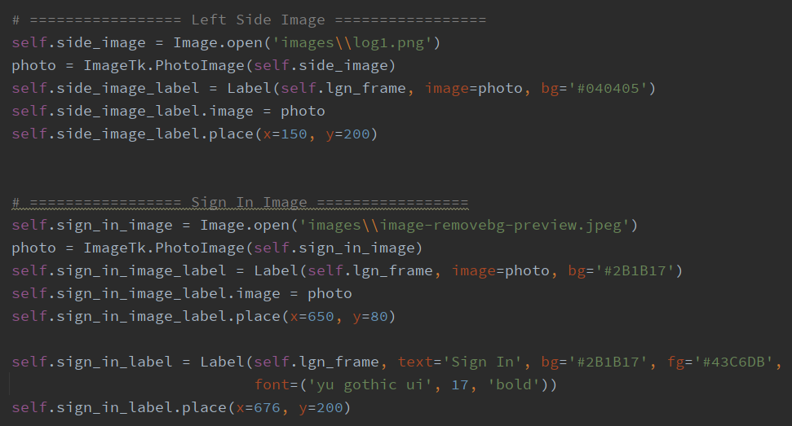

This is Images for sign in and left side image

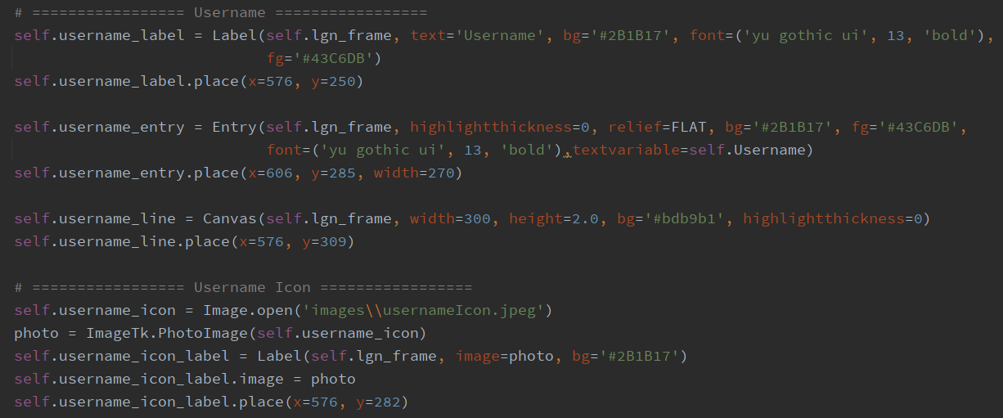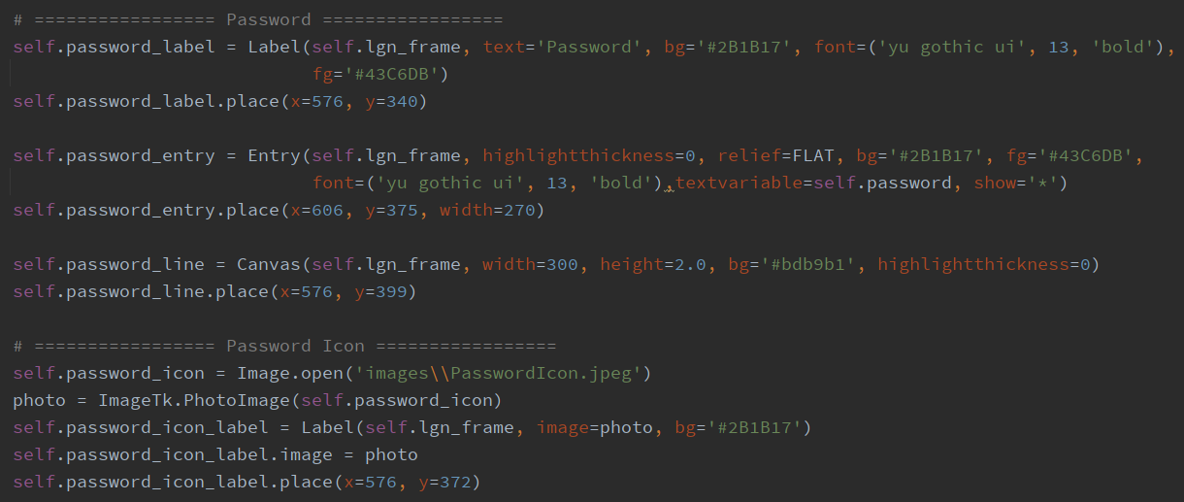

Here is login normal seen username and password both icon and the label including the place for entry

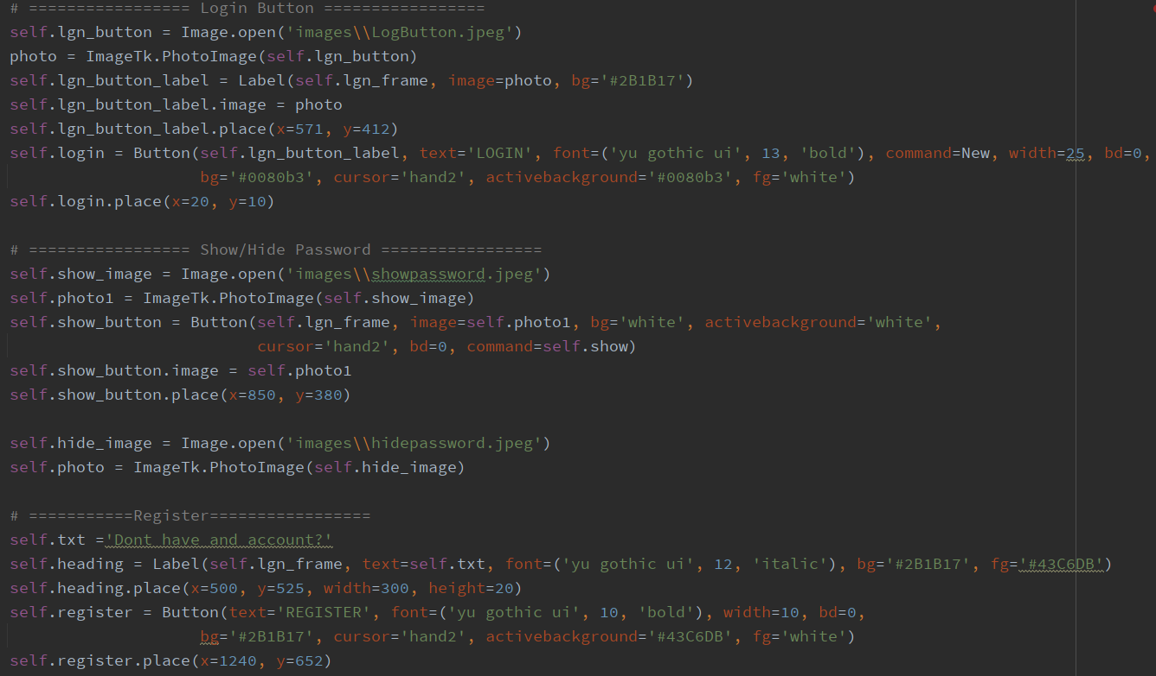

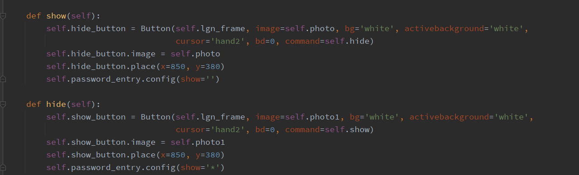

Above this two picture of coding is the code for Login Button and also the fuction for hide and show password.

Homepage(Chai Yi Bing)

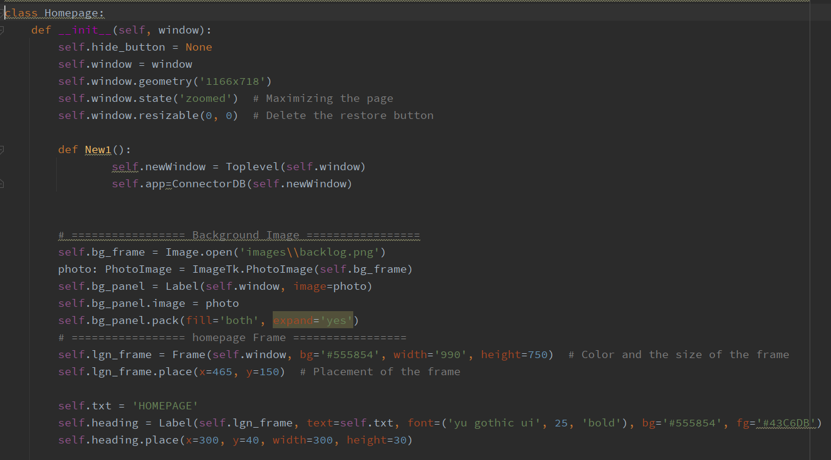

This is the code for declare the page as homepage using class and also the link to new page function called as new1. Other than that, would be the background and homepage.

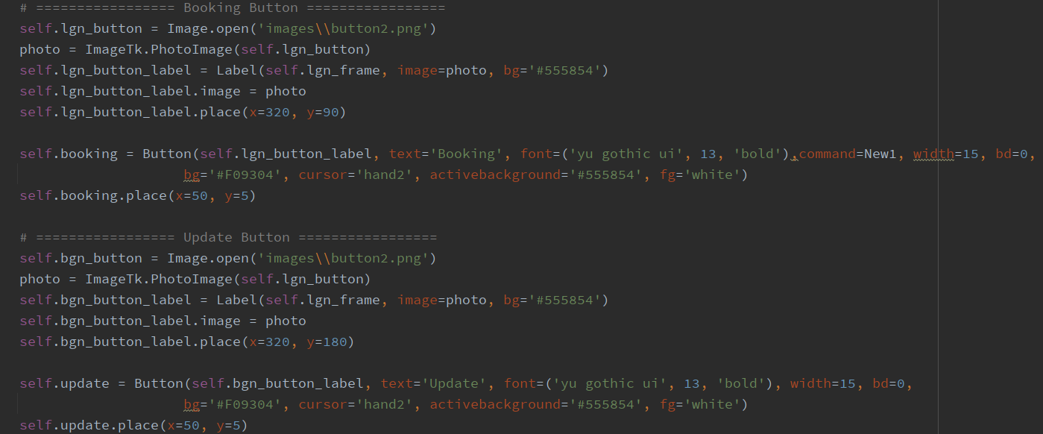

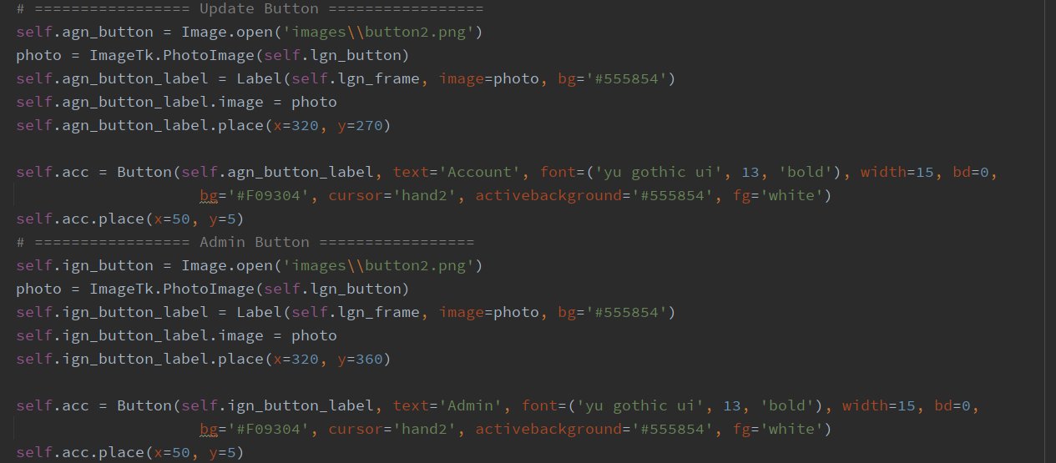

Here is the button code for all the booking,update,account and admin

Booking Page(Chai Yi Bing)

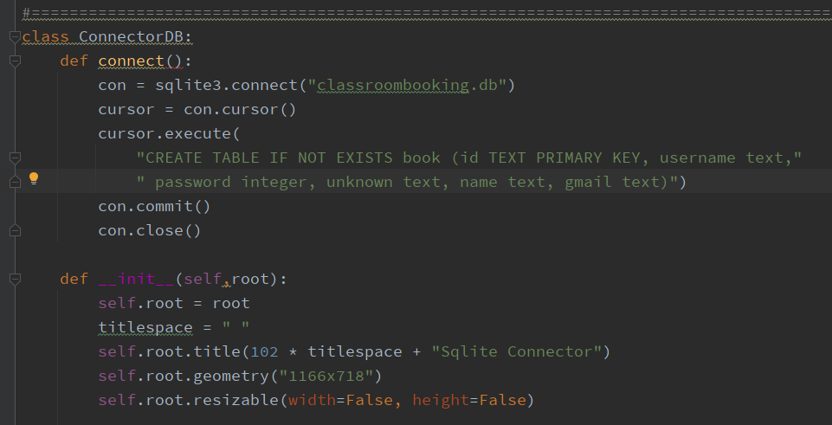

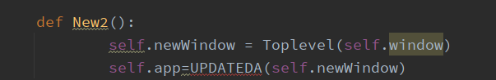

Same again the page declaration and the goto new page code

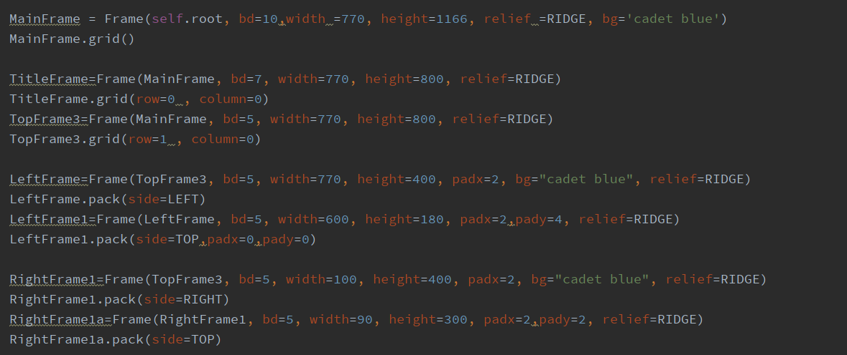

Changed the code for frame a little to be more simple

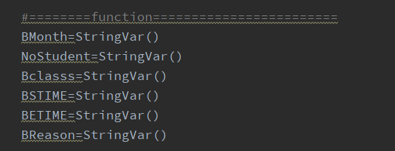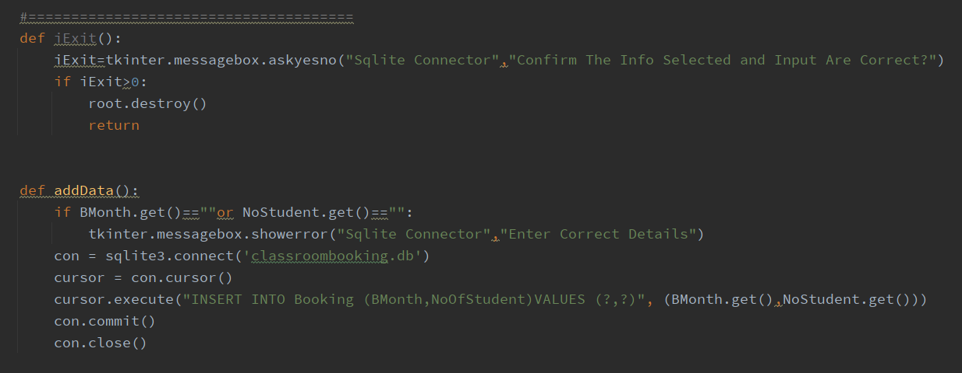

Declaration for the variable and also function for exit and insert data.

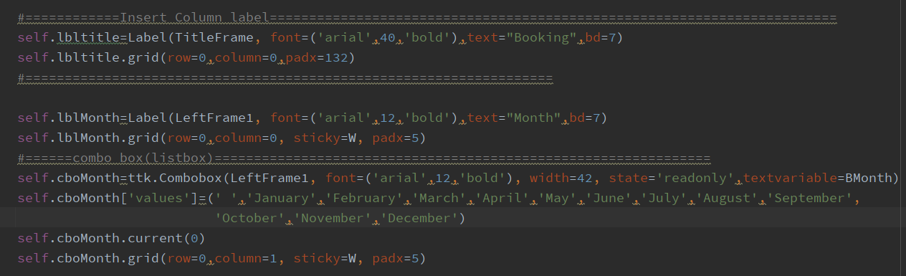

Here is the code for the column title and the label and combo box of Month

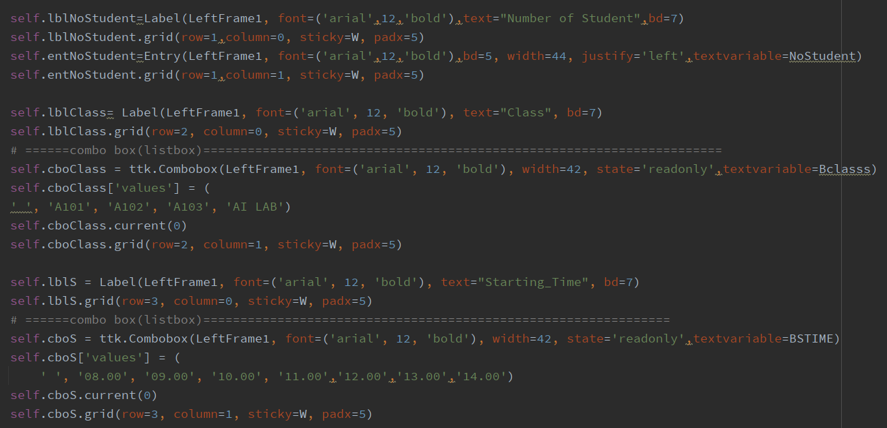

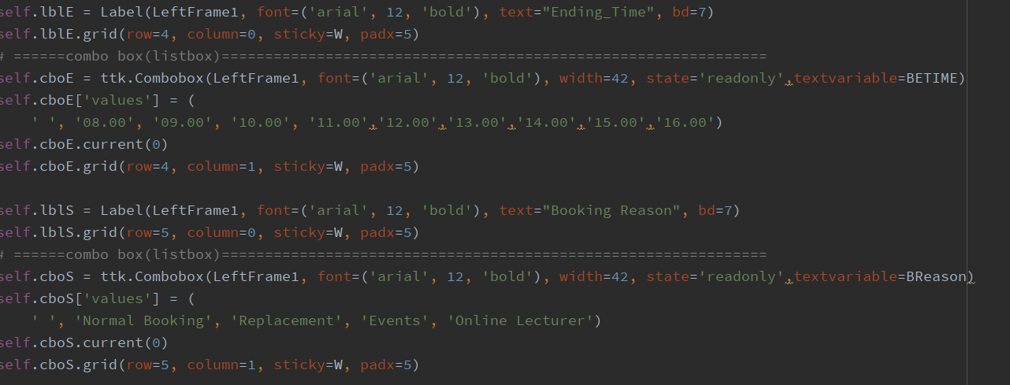

Here is the code for other variables which are Number of student, class, start time, end time and Booking reason for booking.

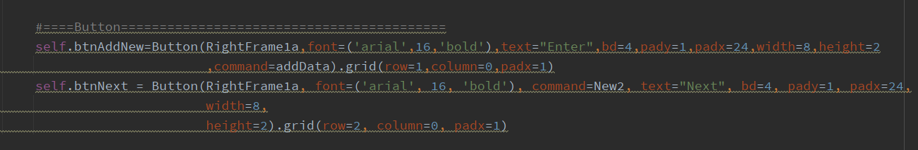

This is the button code and insert command been put to the button.

Update Page(DIvesh Mohan)

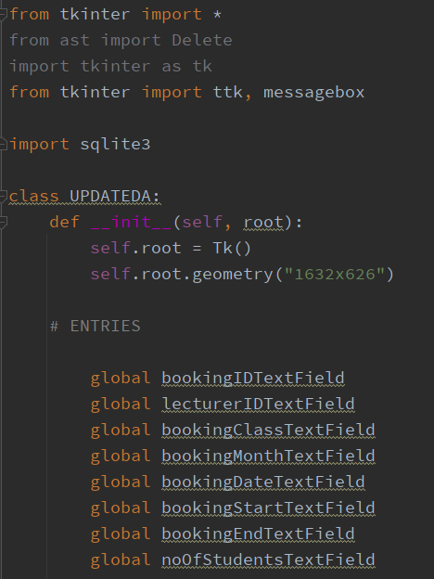  
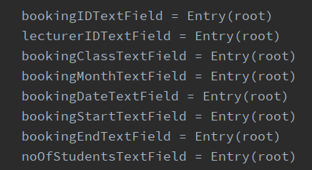

This are all the declaration for the page and the global including entry(root)

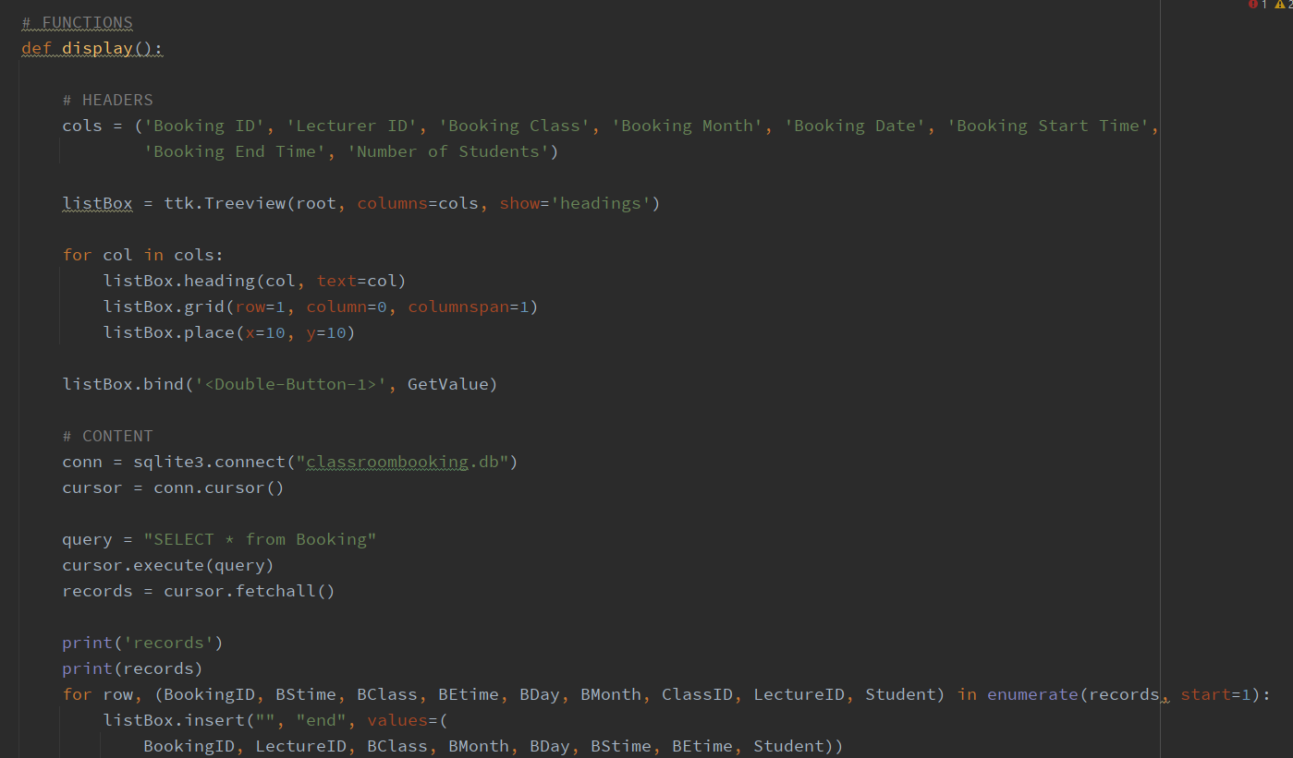

Here is the function code for display

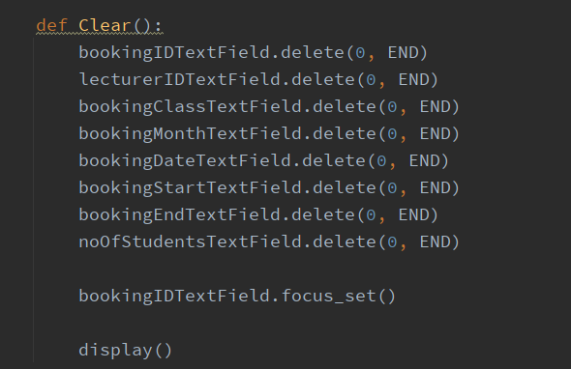

Here is the fuction code for clear which clear all data.

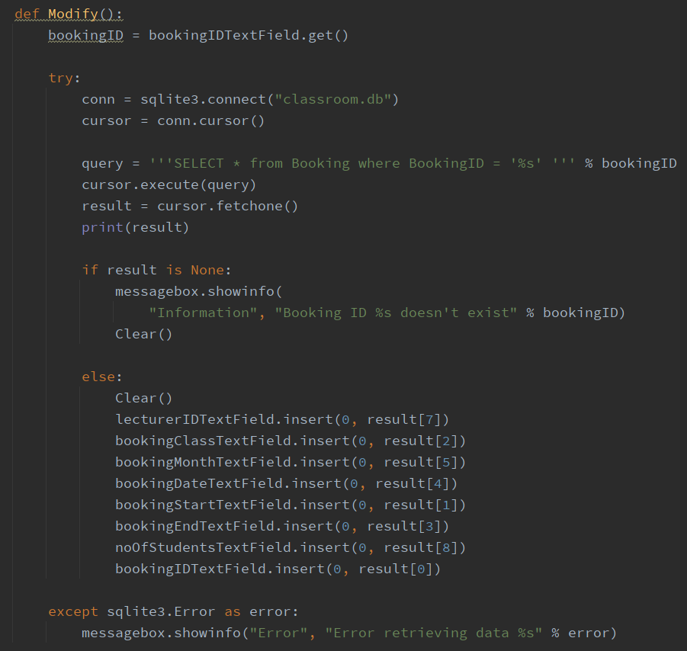

Here is the code for Modify

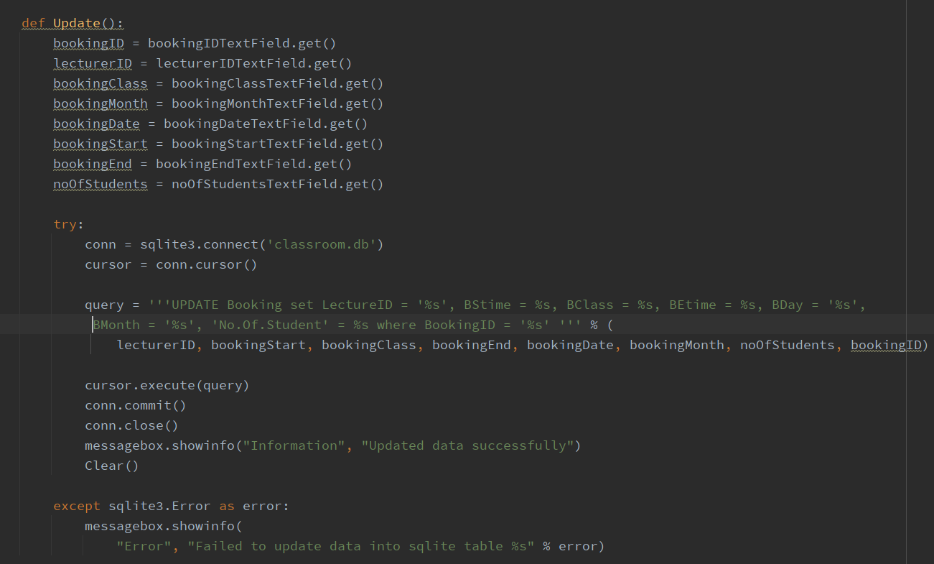

Here is the update function

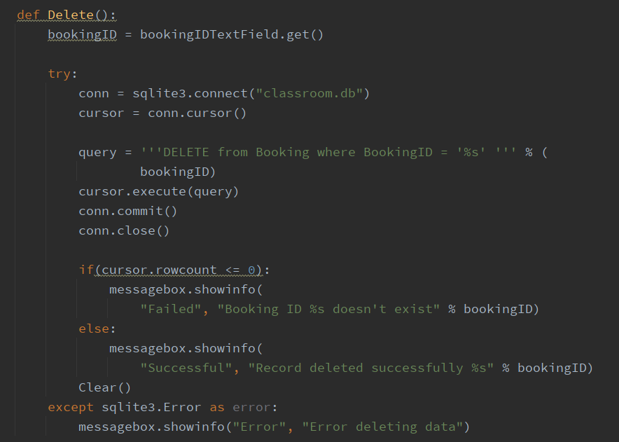

This is the function code for Delete

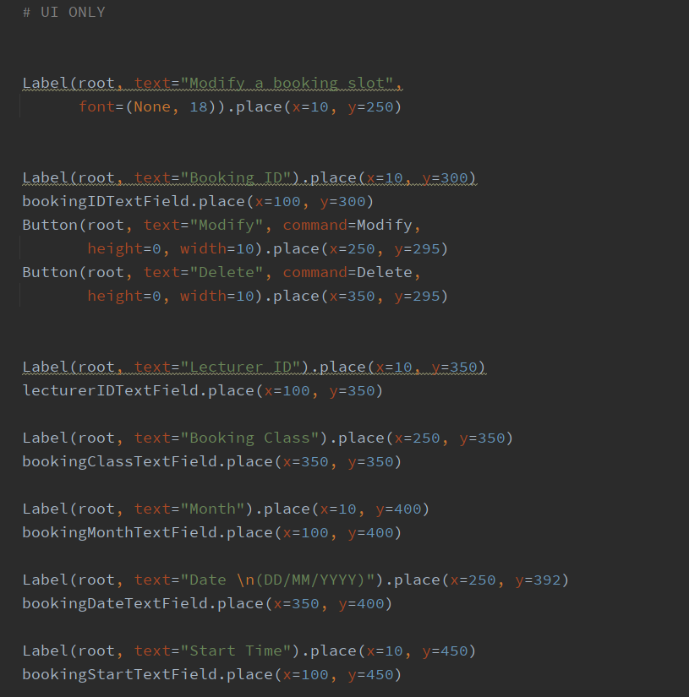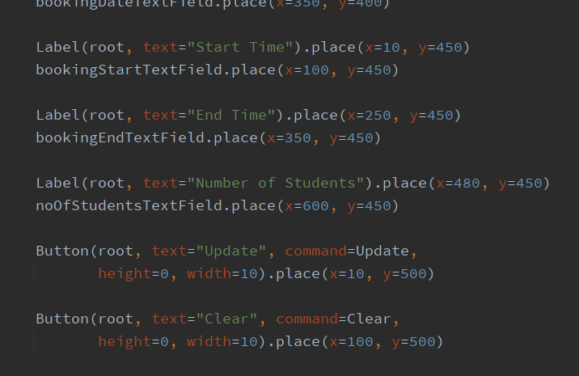

This two above is the code for UI and label

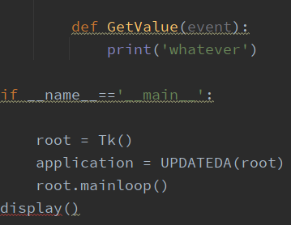

Ended with this.

Account Page(Lee Chee Hong)

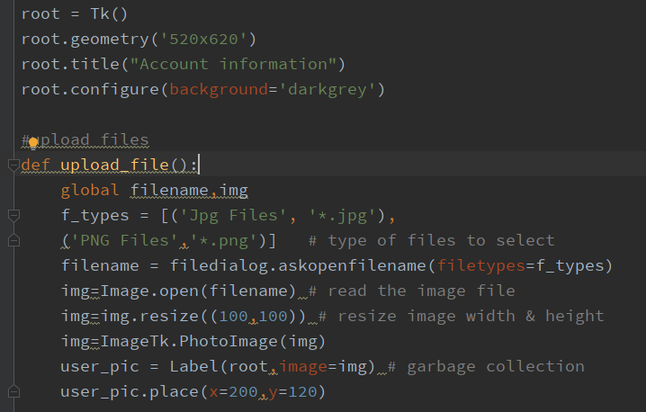

Here is the Import and root other than that would be upload file function.

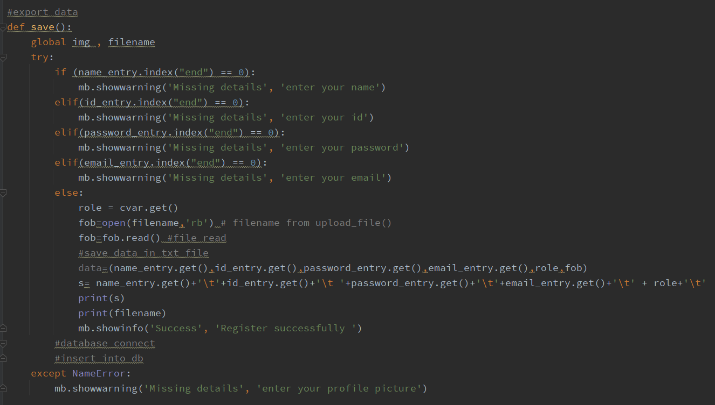

Here is the code for Export data

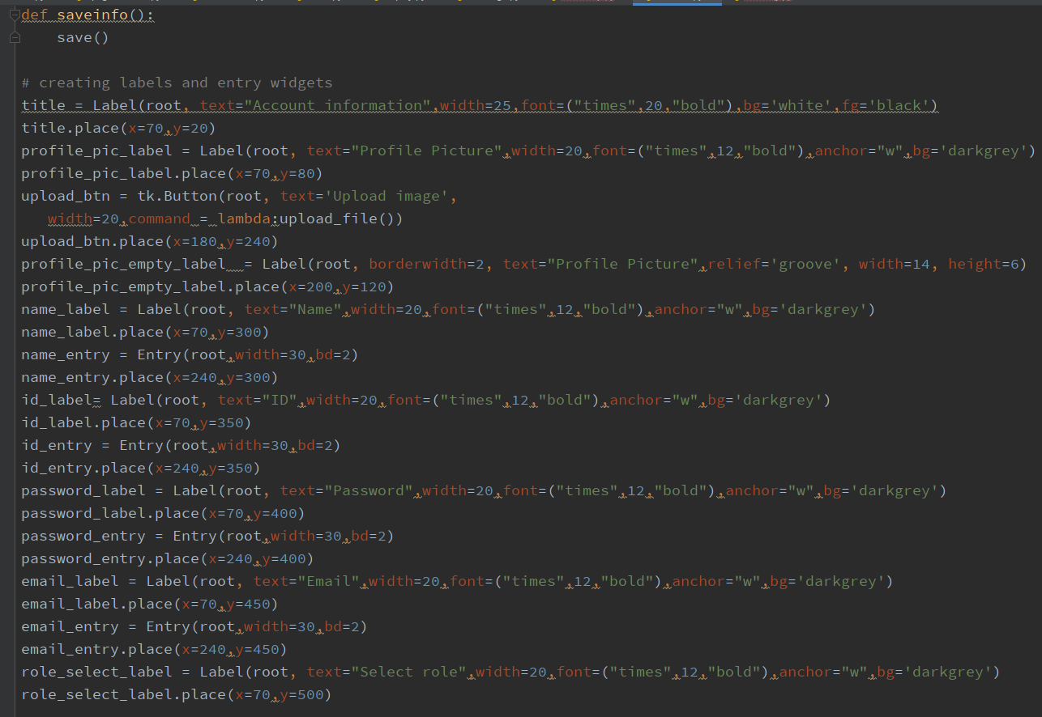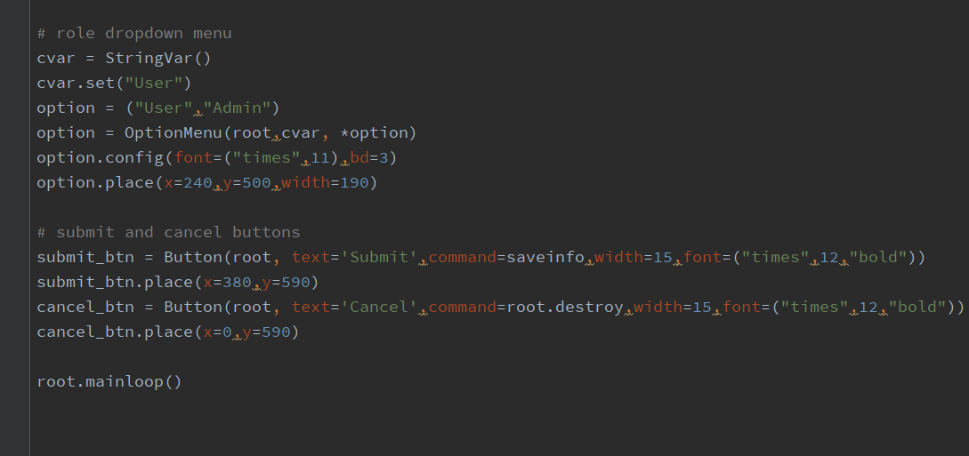

Here are the code for save info function and all the lable and button including the decalaration of variable and command placement.